**CPSC 24500: Getting User Input**

**Summary:** In this assignment you will create a simple menu driven application that would be used by an administrator at the college to enter information about a student. The interface for this application will be a command line interface that will use a Menu Driven approach. What this means is a series of menus will be provided to the user for them to interact with. We’ll be using much of the material covered in our first reading assignment; particularly scanners; ensure you’re familiar with that.

**Requirements:**

*Interface:*

First, the interface must be a command line interface. For this assignment we will only have 1 menu. The options must include: 1. Enter the Students name, 2. Enter the Students Academic Year, 3. Enter the Students GPA, 4. Display Students Info; 5. Exit.

The user will be presented a menu with these 6 options. They will answer with a numeric response of 1,2,3,4, or 5. Based on this response a question will be presented telling them to provide the information they selected (Enter Students Name: , Enter Students GPA, etc). They will provide this information and the menu will be presented again so they may enter another piece of information.

This will repeat until the user selects the Exit option. Let’s take a moment to discuss each option the user can select.

*Variables and Data types:*

For options 1,2,3 you will need to create corresponding variables for the Students_Name, Students_Year, and Students_GPA. How you name these variables is up to you. The name, and year are strings; and the year will be an answer such as Freshmen, Sophomore, Junior, Senior. The GPA is a double and will contain responses such as 2.0, 3.56, 2.89 etc.

*Error handling:*

Error handling must be included for options 2, 3, number 4 is optional extra credit (see extra credit section). You must ensure the user provides the correct year and that the GPA they provide is not only a double, but is also not above 4.0; 0.0 is acceptable as the lower threshold.

For the error handling on option 2, you can enforce standards you choose. FRESHMAN can be all uppercase, or Only the first letter capitalized, or all lowercase. As long as your error handling enforces your standard, I will accept it.

Number 5 doesn’t require error handling as it simply exits the program.

General error handling is assumed. Remember our section on try/catch.

*Methods:*

Generally speaking, you should follow a standard of separating your code into relevant functions/methods/classes; however, as this assignment is rather simple this specification will be simple. A minimum of 2 methods should be created: one to print out the main menu, and one to determine if all of the required variables have been populated correctly. By this I mean you validate that the provided input from the user matches your requirements. You may name that as you see fit.

This means at a minimum you should have 3 methods within your program. The main method, a method to confirm if all the required variables have been populated correctly, and a method to print the menu.

**Extra credit:**

With each assignment some extra credit will always be available for those who want to get ahead or learn more. Each extra credit you do will be worth 1 point.

1. Find a way to clear the terminal screen in a useful and meaningful way. This can help keep clutter down and prevent confusion for the user. If you implement this please ensure you have a way to make sure I can read the output from option 4. You might find if you clear the terminal too quickly, or without asking the user to continue, we can’t confirm information.
2. Add an additional check that ensures all of the variables have been filled out (and correctly) before Number 4 will print anything. If the user is missing any input (student name is blank, GPA not entered, etc.) print “Please answer all questions”.
3. Related to number part 2, rather than print “Please answer all questions” Tell the user which option or options they are missing. If you can present the user with all of the options, they are missing you will get full credit. If you can only present the user with one at a time until all have been answered you will receive partial credit.

**Grading:**

Below is the criteria I will use to grade your work. Each is worth 1 point, some will be broken into half points. These will be notated and explained.

1. Comments – at a bare minimum your name should be provided at the top. In order to get the full 1 point you must have meaningful comments as well. If you only put your name you will receive only .5 points.
2. Your program is named LastNameHandlingInput.java. You will replace LastName with your actual last name.
3. The menu options are displayed on a terminal
4. The method to show the menu is written (mentioned earlier)
5. The menu will continue to be displayed and ask for input until the user selection option 6.
6. The user is able to answer question 1.
7. The user is able to answer question 2.
8. The user is able to answer question 3.
9. The user is able to answer question 4.
10. The user is able to exit with 5.
11. Error handling for 2 prevents the user from entering anything other than Freshman, Sophomore, Junior, Senior.
12. Error handling for number 3 prevents the user from entering anything other than a double between 0.0 and 4.0.

If your program crashes due to code issues while executing you will lose 6 points (half of all potential points). Ensure error handling as outline is implemented, and build in try/catch especially when writing files.

If your program cannot compile you will receive no credit. I will be testing all of your code on the Ubuntu VM discussed. If you’d like me to compile and execute on Windows please let me know when you turn in your assignment. While this shouldn’t be an issue, some things, like clearing the terminal, can result in errors from Windows-Linux.

I am a strong supporter of open source development, and I encourage you to review code and learn on resources such as Stack Overflow. With that said, I believe it’s important to understand the code you’re writing. Copying and pasting from Stack Overflow, Reddit, other students work, or other resources will result in -12 points. There may be instances where I note that copying from Stack Overflow or an open source project is acceptable. I will do so. Please do your own work, learning using Stack Overflow is very important, but do not copy and paste. If you ever have any trouble where you feel you can’t get past a requirement let me know. I will gladly help you.

Example of running program:

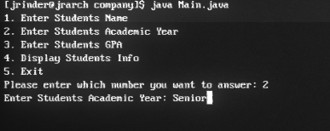

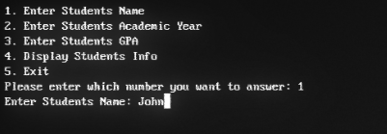

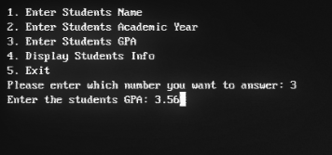

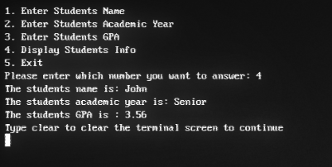

Once the user types clear the terminal session will clear and the user will be able to answer the questions again. Your menu and output should be almost exactly like mine. If you have any questions let me know.

Once the assignments have been graded I’ll provide the source code so you can review.